Dot1x (.1x) Authentication Issues on Mac
Official URL: https://services.smsu.edu/TDClient/180/Portal/KB/Article/4376/Dot1x-1x-Authentication-Issues-on-Mac
Category: Knowledge Base > Information Technology Services > Internal > Dot1x (.1x) Authentication Issues on Mac
Tags: mac, Dot1x
_____________________________________________________

Overview
When a Mac is connected to Ethernet, it may fail to authenticate over 802.1X if the network settings or saved credentials are incorrect. This can result in login issues, persistent certificate popups, and a self-assigned IP address, which causes network slowdown or complete disconnection. This guide walks you through identifying and resolving 802.1X authentication issues on macOS, including clearing problematic keychain entries and re-establishing proper certificate trust.

Symptoms of 802.1X Authentication Failure
- Repeated popups asking to trust a network certificate.
Repeated popups asking to trust a network certificate.
- Ethernet interface shows a self-assigned IP in System Settings > Network.
Ethernet interface shows a self-assigned IP in System Settings > Network.
- Internet is slow or unavailable despite being plugged into Ethernet.
Internet is slow or unavailable despite being plugged into Ethernet.

Step-by-Step Resolution
- Check for Self-Assigned IP
Open System Settings.
Go to Network.
Select Ethernet.
If the IP address starts with 169.254, the Mac is not authenticating properly.
- Open System Settings.
Open System Settings.
- Go to Network.
Go to Network.
- Select Ethernet.
Select Ethernet.
- If the IP address starts with 169.254, the Mac is not authenticating properly.
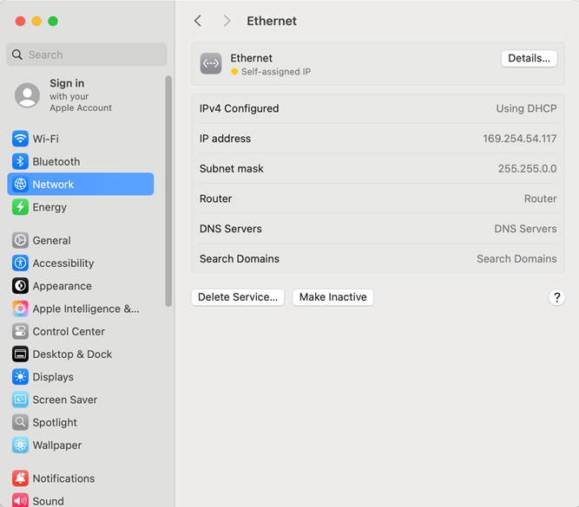
Figure 1: Screenshot
- Attempt Quick Fix via Certificate Popup
If a certificate popup appears:
Set the certificate to [Computer Name].smsu.edu.
Enter admin credentials when prompted.
If this resolves the issue, Ethernet should now show a green dot and a valid IP.
If the popup does not appear or the issue persists, continue to the next steps.
Attempt Quick Fix via Certificate Popup
If a certificate popup appears:
- Set the certificate to [Computer Name].smsu.edu.
- Enter admin credentials when prompted.
If this resolves the issue, Ethernet should now show a green dot and a valid IP.
If the popup does not appear or the issue persists, continue to the next steps.
- Remove Corrupt 802.1X Profile from Keychain
Open Spotlight (top-right corner of the screen).
Search for Keychain Access and open it.
Enter the current user’s credentials if prompted.
In the top-right search bar, type SMSU.
Look for an entry similar to: com.apple.network.eap.system.identity.profileid.(A1B2C4-1508-48CC-A9BB-D7FHL1541GC6)
Select the entry and press Delete.
Enter admin credentials (refer to the SMSU admin credentials article).
- Open Spotlight (top-right corner of the screen).
Open Spotlight (top-right corner of the screen).
- Search for Keychain Access and open it.
Search for Keychain Access and open it.
- Enter the current user’s credentials if prompted.
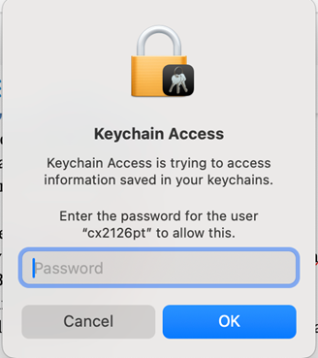
Figure 2: Screenshot
- In the top-right search bar, type SMSU.
In the top-right search bar, type SMSU.
- Look for an entry similar to: com.apple.network.eap.system.identity.profileid.(A1B2C4-1508-48CC-A9BB-D7FHL1541GC6)
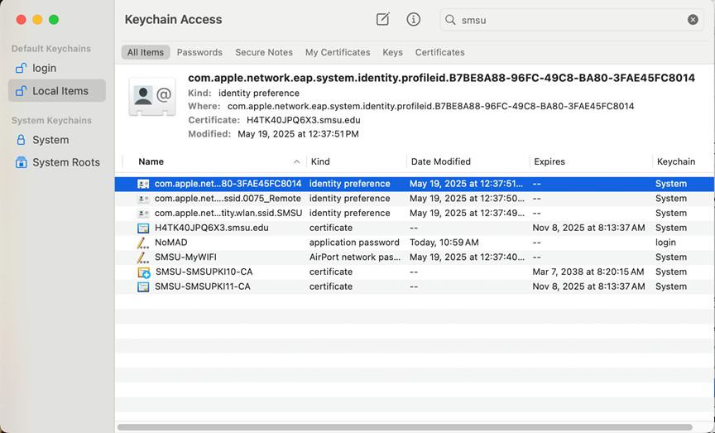
Figure 3: Screenshot
- Select the entry and press Delete.
Select the entry and press Delete.
- Enter admin credentials (refer to the SMSU admin credentials article).
Enter admin credentials (refer to the SMSU admin credentials article).
- Reconnect Ethernet and Re-authenticate
Unplug the Ethernet cable.
Plug it back in to trigger the certificate popup.
If the popup appears: Set the certificate to [Computer Name].smsu.edu and enter admin credentials to save.
If the popup does not appear: Go to System Settings > Network then select Ethernet and click Details.
Go to the 802.1X tab.
Click Connect (or Disconnect and then Connect).
Ensure the profile is set to Wifi(SMSU)
When the popup appears, select [Computer Name].smsu.edu and click ok
It’ll ask for admin credentials enter them and authenticate
Reconnect Ethernet and Re-authenticate
- Unplug the Ethernet cable.
Unplug the Ethernet cable.
- Plug it back in to trigger the certificate popup.
If the popup appears: Set the certificate to [Computer Name].smsu.edu and enter admin credentials to save.
If the popup does not appear: Go to System Settings > Network then select Ethernet and click Details.
Plug it back in to trigger the certificate popup.
If the popup appears: Set the certificate to [Computer Name].smsu.edu and enter admin credentials to save.
If the popup does not appear: Go to System Settings > Network then select Ethernet and click Details.
- Go to the 802.1X tab.
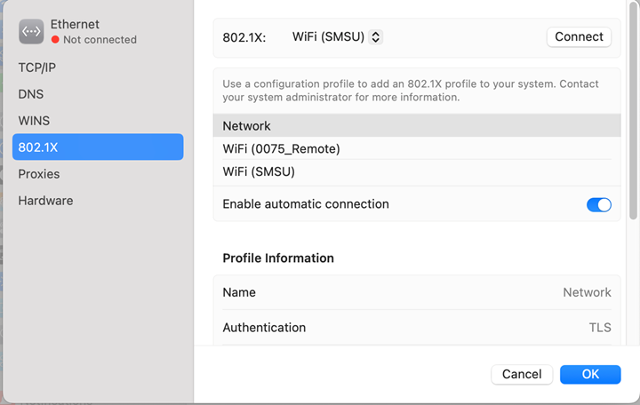
Figure 4: Screenshot
- Click Connect (or Disconnect and then Connect).
Click Connect (or Disconnect and then Connect).
- Ensure the profile is set to Wifi(SMSU)
Ensure the profile is set to Wifi(SMSU)
- When the popup appears, select [Computer Name].smsu.edu and click ok
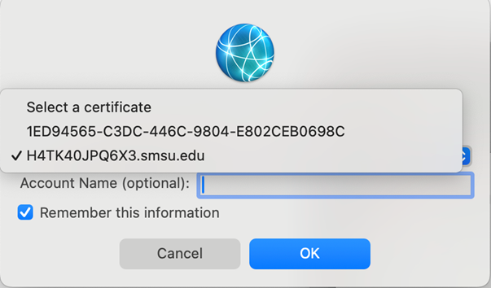
Figure 5: Screenshot
- It’ll ask for admin credentials enter them and authenticate
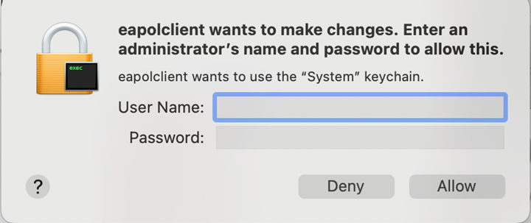
Figure 6: Screenshot
- Confirm Successful Authentication
Return to System Settings > Network: Ethernet should now show a green dot and a valid IP address (not self-assigned)
no further certificate popups.
Confirm Successful Authentication
- Return to System Settings > Network: Ethernet should now show a green dot and a valid IP address (not self-assigned)
Return to System Settings > Network: Ethernet should now show a green dot and a valid IP address (not self-assigned)
- no further certificate popups.
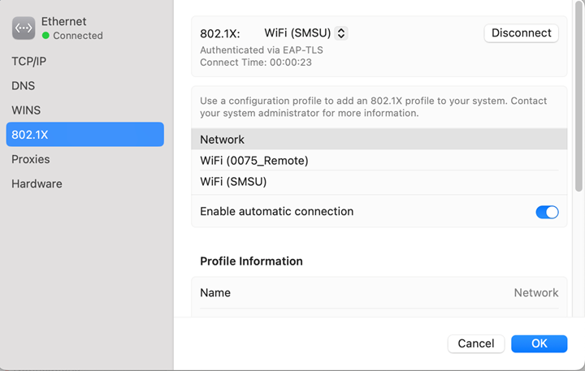
Figure 7: Screenshot
Accessibility Review & Update Log:
- [x] Content accuracy and link integrity verified
- [x] High-contrast visual hierarchy implemented (Inter and Calibri)
- [x] Image alt-text captions verified (all screenshots captioned)
- [x] PDF attachments scraped and fully inlined directly inside the document
- [x] Outline headers and standard list sequences optimized for screen readers

